Data Curation: Diffusion Couple- Rene88-IN100

1. To start this tutorial, we first need to upload the “DemoDiffusion” template. So we start Administrator dashboard and “Templates &Types” menu.

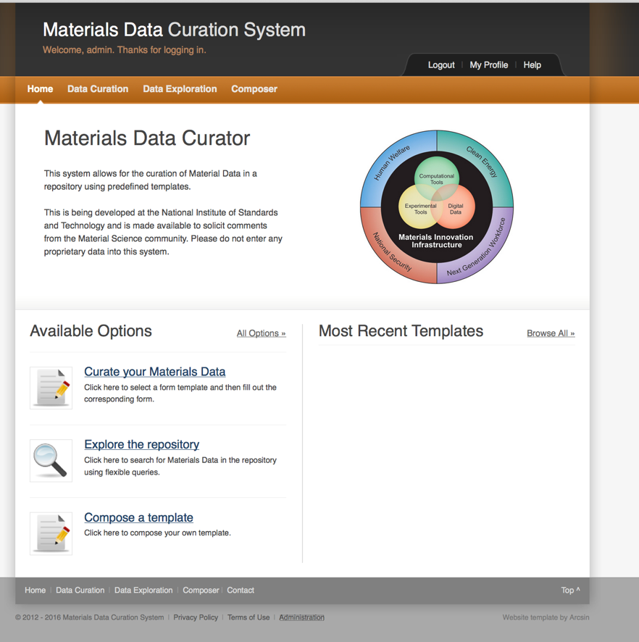

1. Under the “Template & Types” window, select upload template.

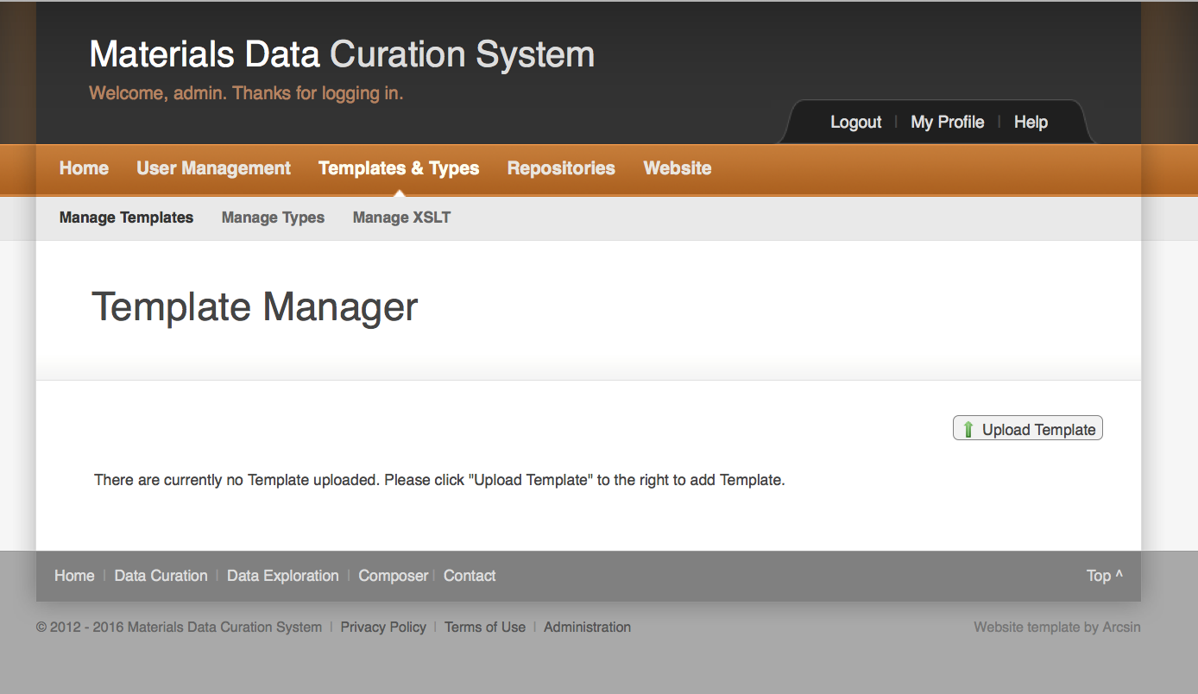

1. Upload the “mod.demo.diffusion.xsd” template and label it “DiffusionDemo”

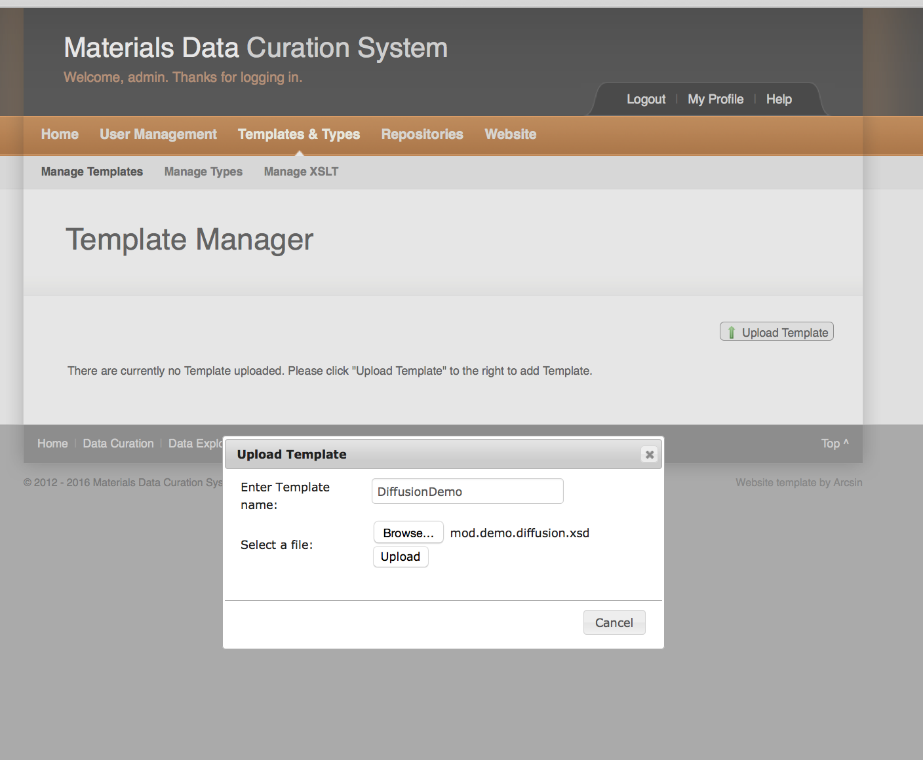

When you have located the file and named the template, click upload. If the upload is successful, you will get a message telling you that you can save the template to the MDCS.

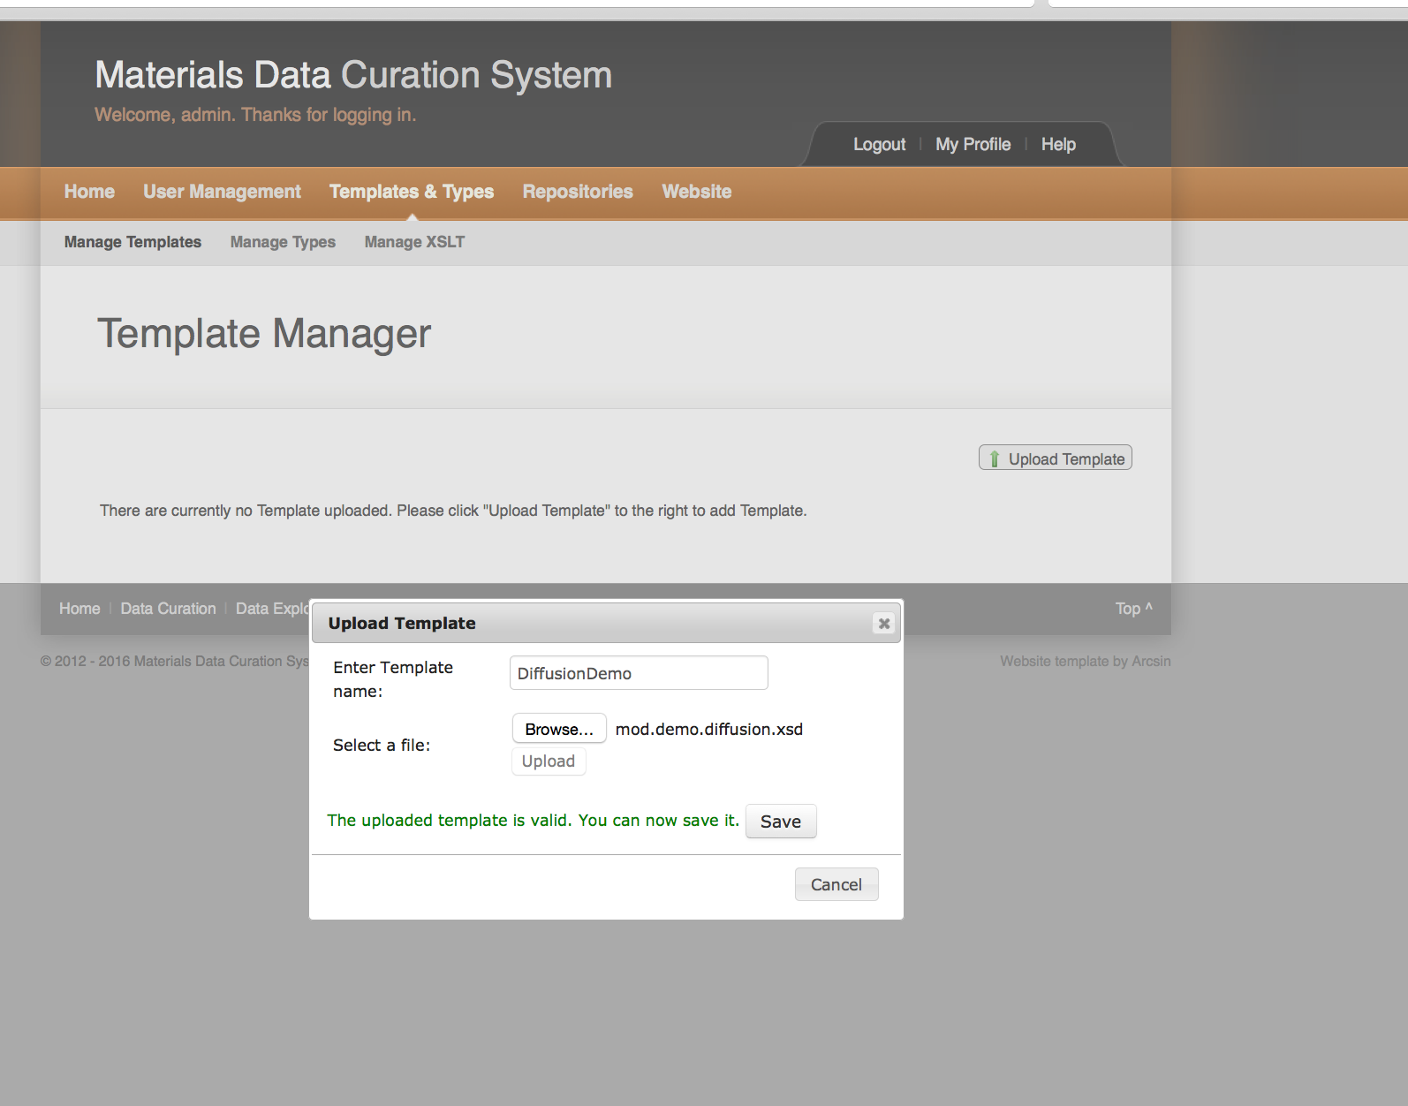

The saved template will then appear in the “Template Manager”

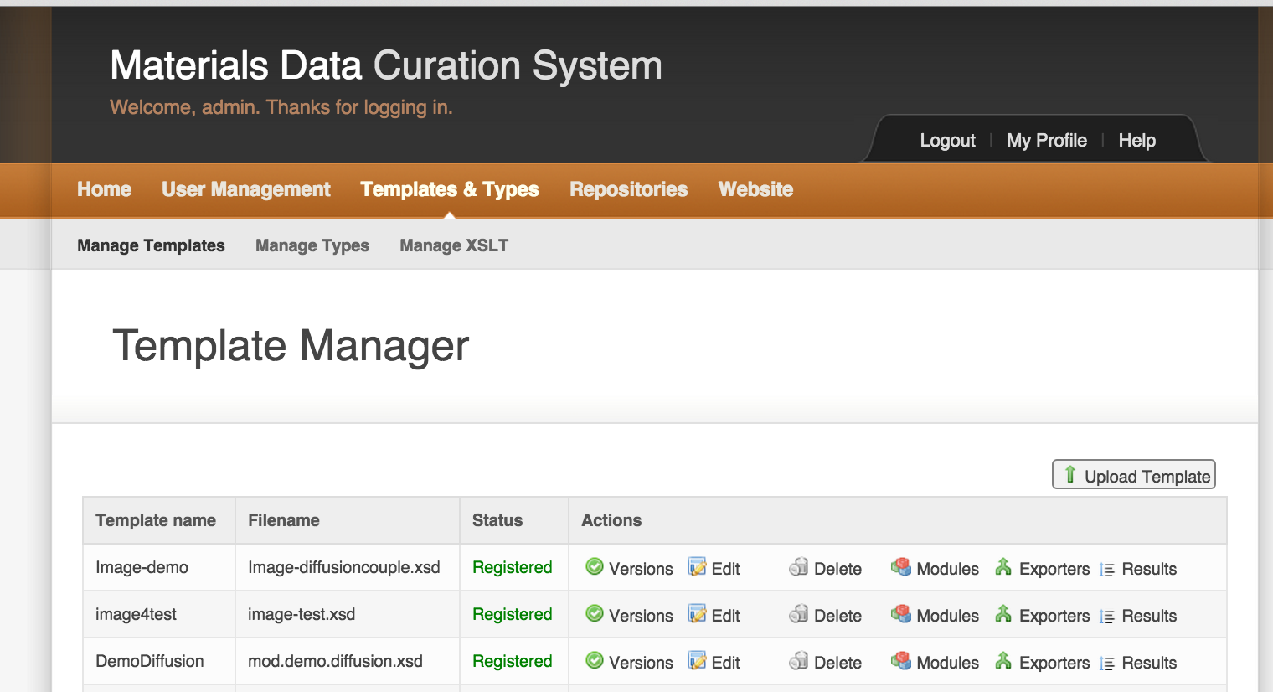

DiffusionDemo

Now that the template has been loaded, we check the available “Exporter” options. To do this click on the “Exporters” in the “DiffusionDemo” row.



DiffusionDemo

Next a menu with a choice of available options will appear

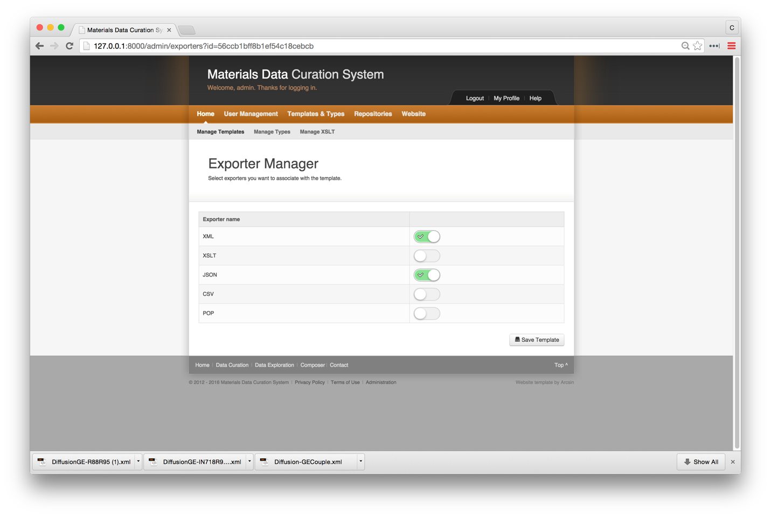

Chose to toggle on the CSV exporter.

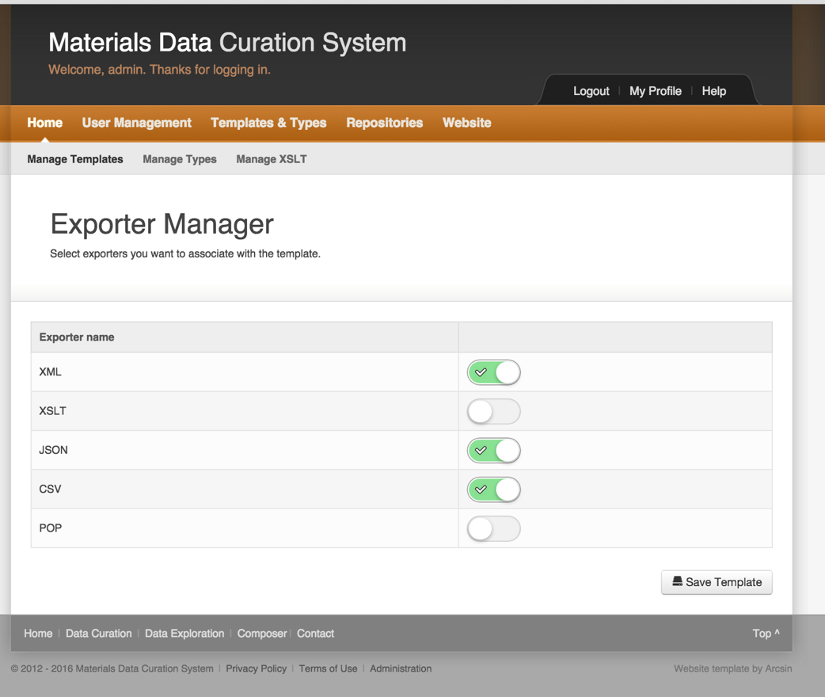

You will then be asked to save the template.

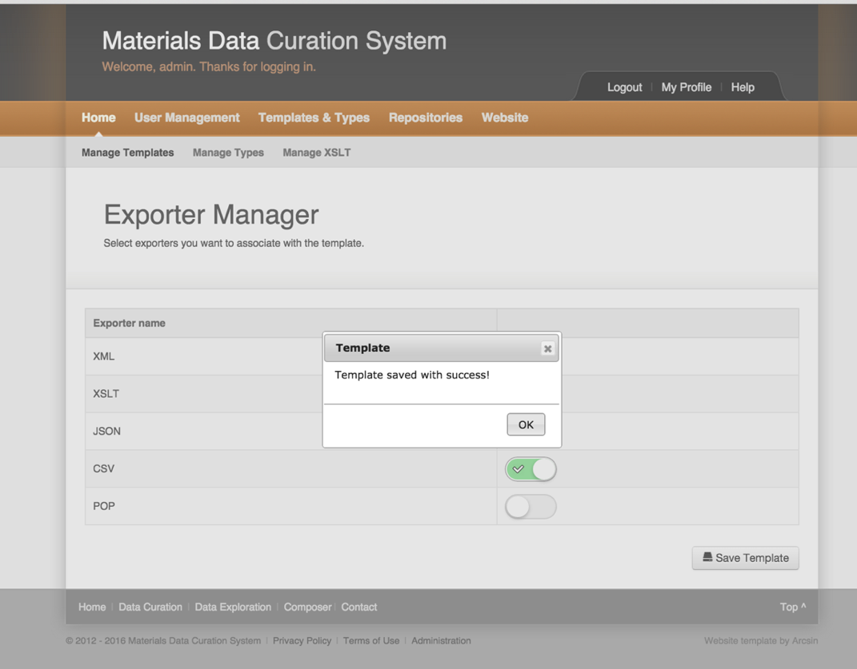

After adding the “Exporters,” return the Template Manager

Now we are ready to curate some data related to a diffusion couple between IN100 and Rene-88 which had a diffusion anneal for 1000 h at 1150 C. We will be entering some metadata about the experiment, the collected composition profile and corresponding micrograph of the diffusion couple.

So return to “Home” screen.

From the “Home” screen, select “Data Curation” on the navigation ribbon or from the “Available Options”



Select “DemoDiffusion” template in the Data Curation Menu

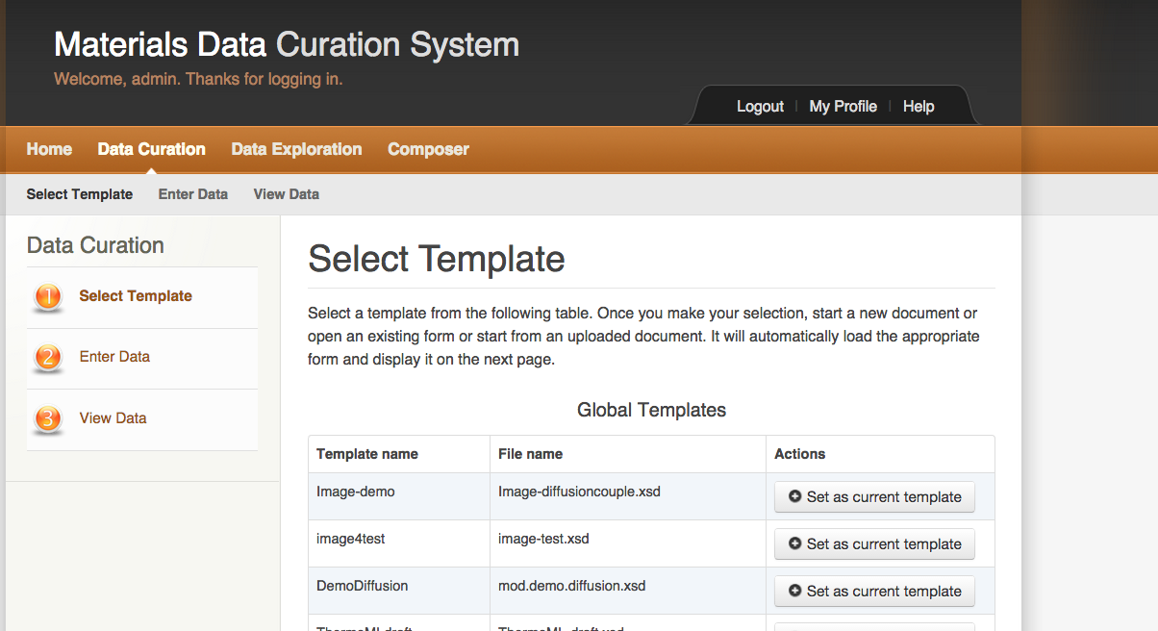

DiffusionDemo

1. Create a new document “R88IN100”

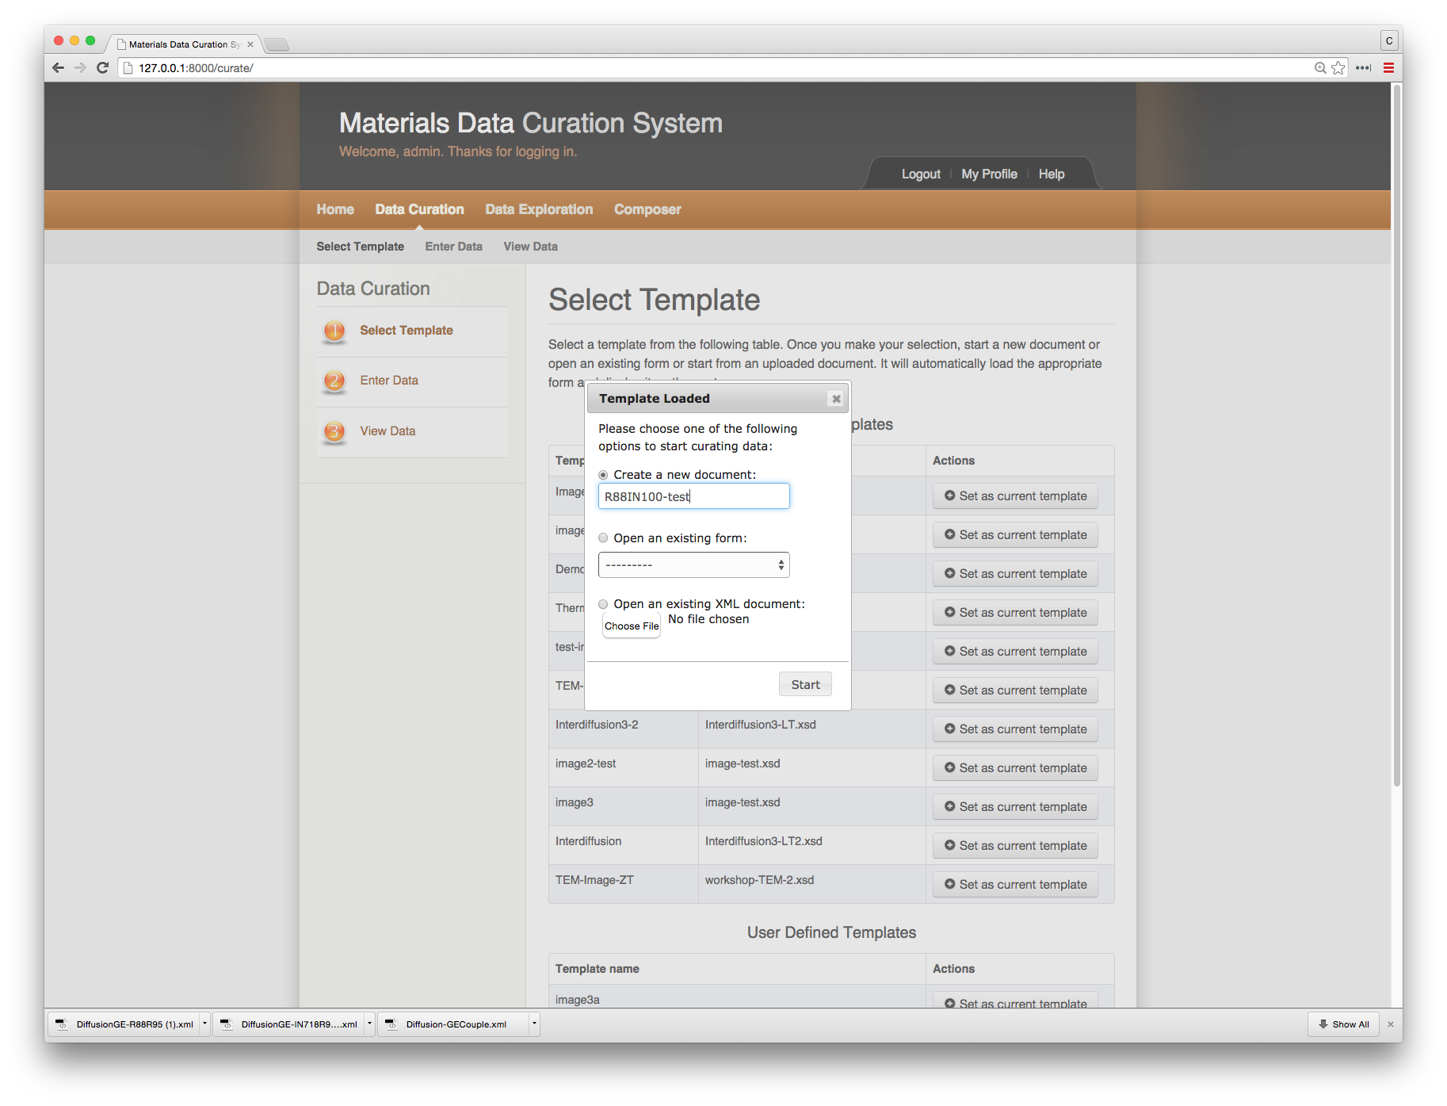

1. The next step is to select the type of diffusion experiment. In this case it is “chemical diffusivity”

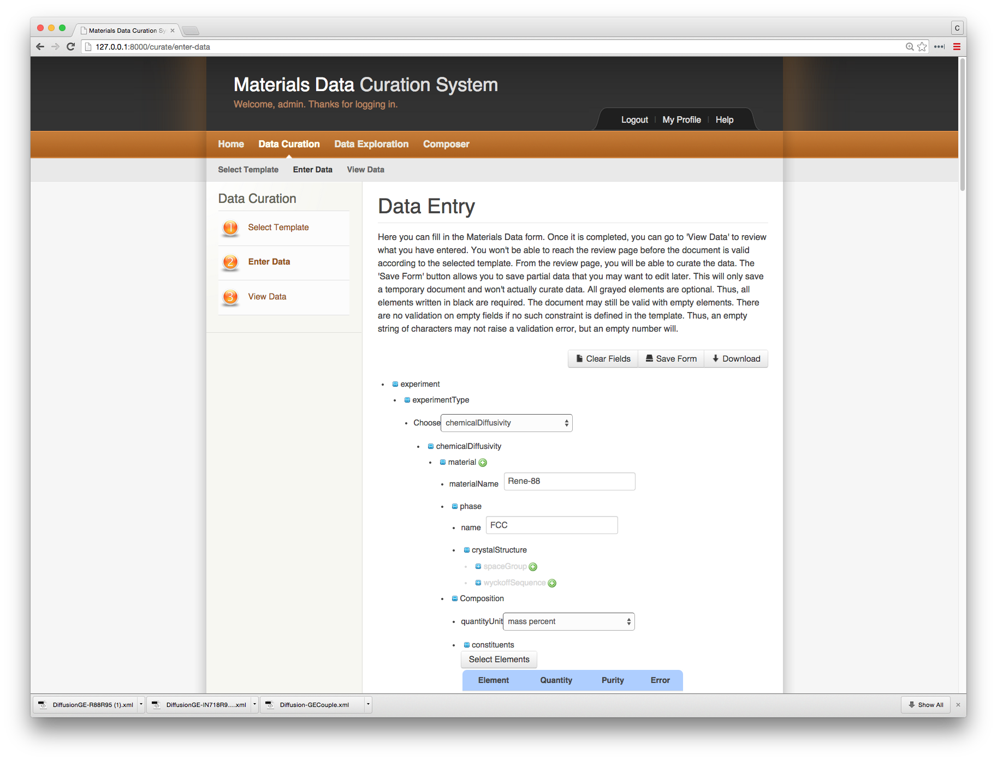

Next enter the information at about the diffusion couple end-members. First, the information for Rene-88.

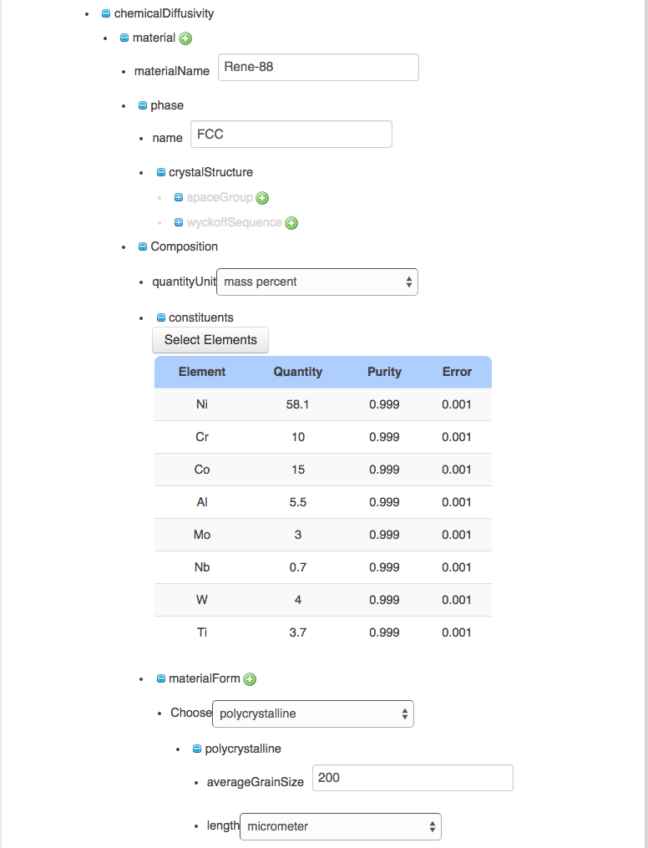

Now enter the information for IN100 alloy.

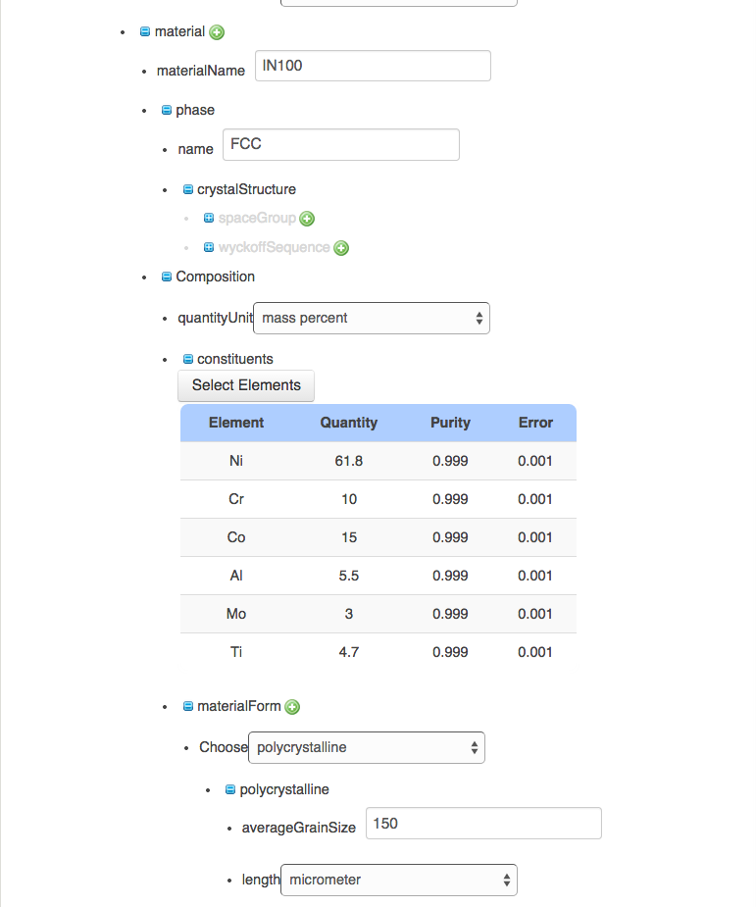

Next, enter the experimental conditions for the diffusion anneal.

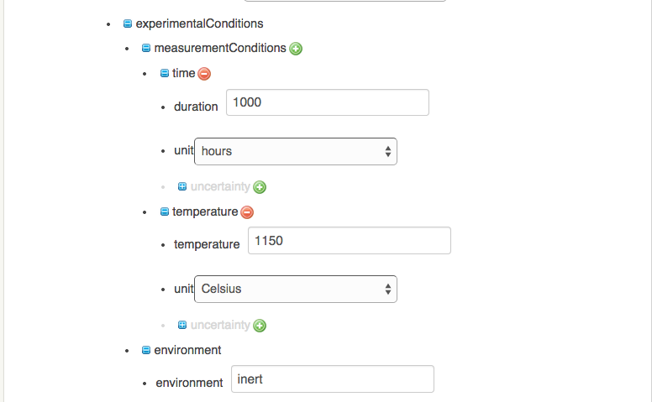

Enter the sample geometries for the two end-members of the diffusion couple.

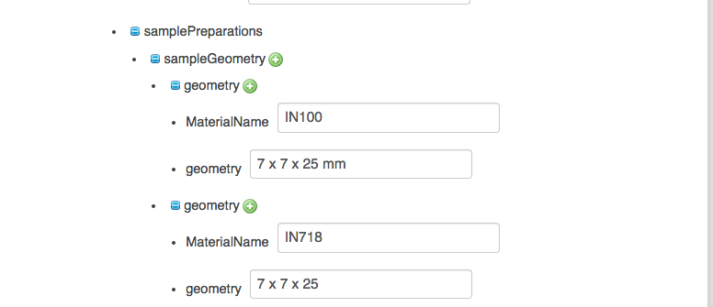

Next enter some sample preparation information. Note these are just text strings.

Sample Preparation Procedure Name: HIP’ing

Procedure Description: HIP at 140 MPa, 1150 °C for 4 h

Sample Preparation Procedure Name: Diffusion anneal

Procedure Description: Encapsulated in an evacuated quartz tube and backfilled with argon. Annealed at 1150 C and water quenched

Sample Preparation Procedure Name: Metallographic Preparation

Procedure Description: The diffusion multiples were cut into two halves in a parallel orientation to the end cap disks. The cut surfaces were ground and polished.

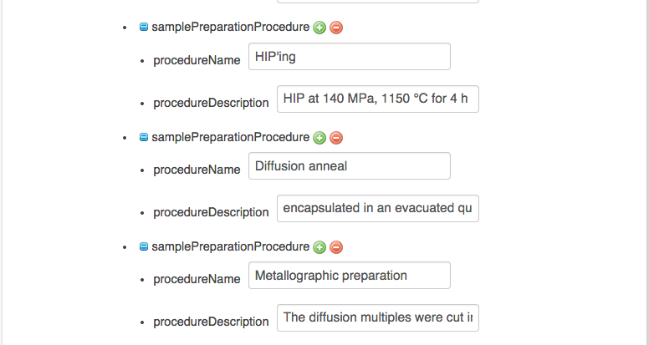

Now enter some information on the data collected. The composition profiles for this experiment were collected using EPMA.

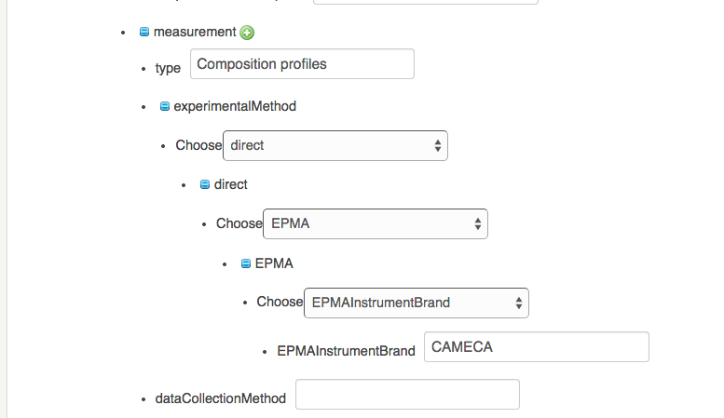

Now enter the collected experimental composition profile (upload an excel spreadsheet: GE-DiffusionCouple-R88-IN100.xlsx)

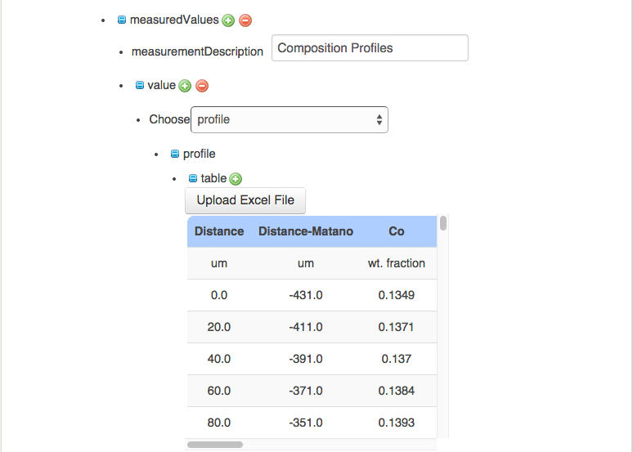

Next upload the corresponding micrograph (GE-DiffusionCouple-R88-IN100.tif)

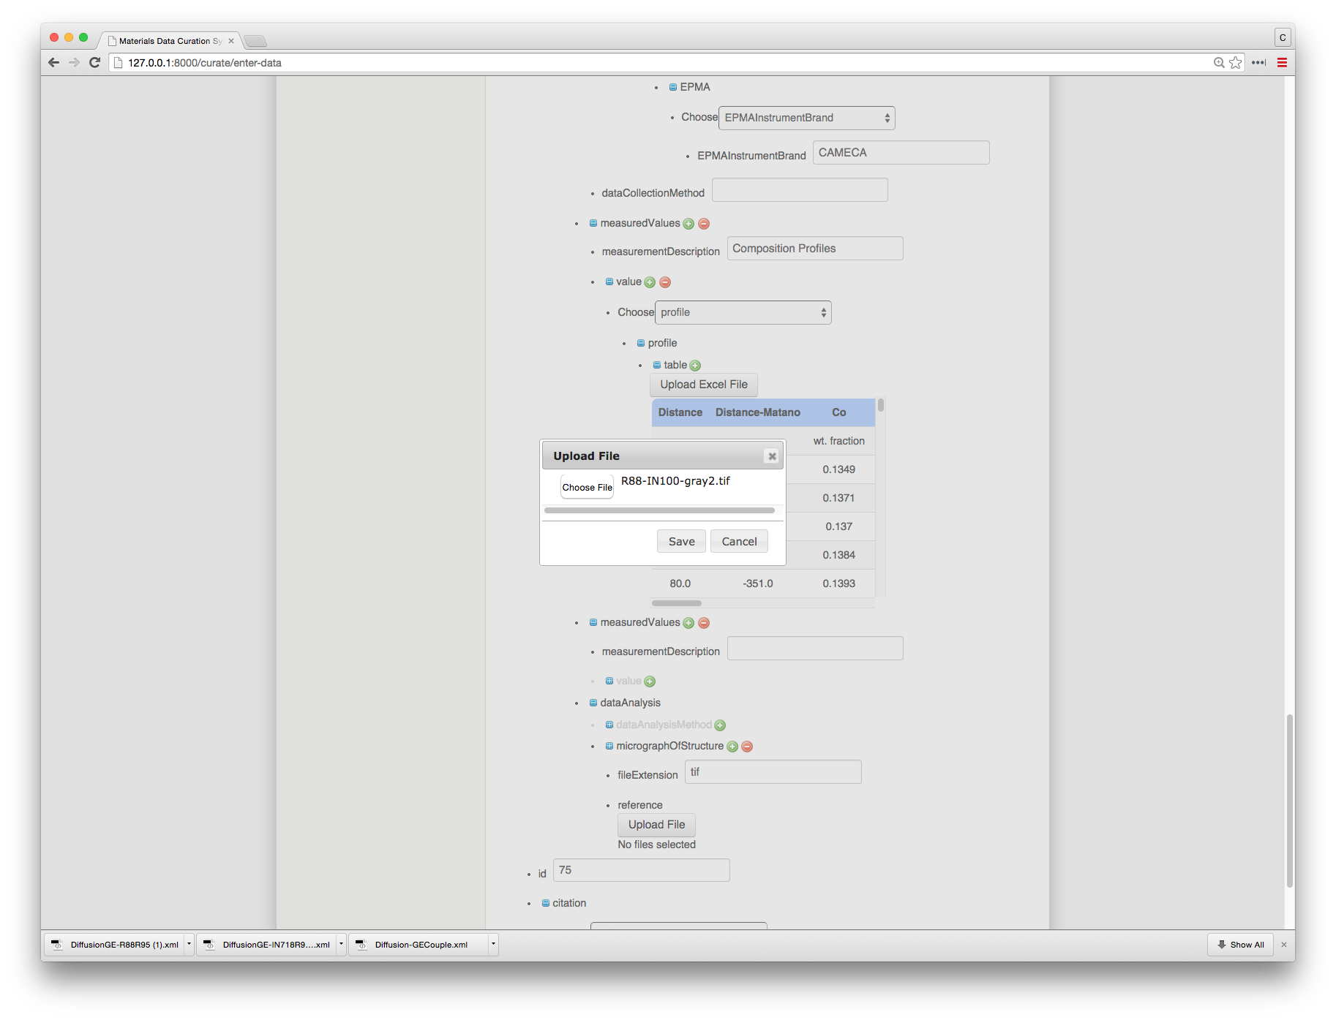

Once the file is upload, you should see a handle reference where the image is stored.

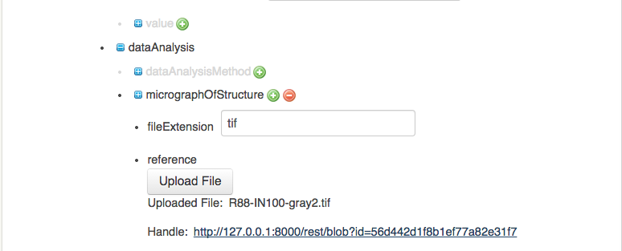

Enter a sample id and chose a citation reference:

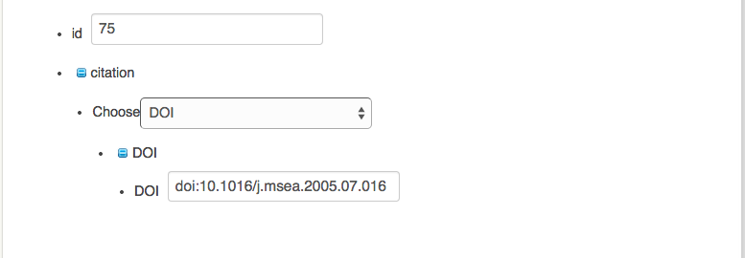

Now you can “View Data” (from the top left hand side menu) and chose to save it to the repository as “GE-DiffusionCouple-R88-IN100.xml.

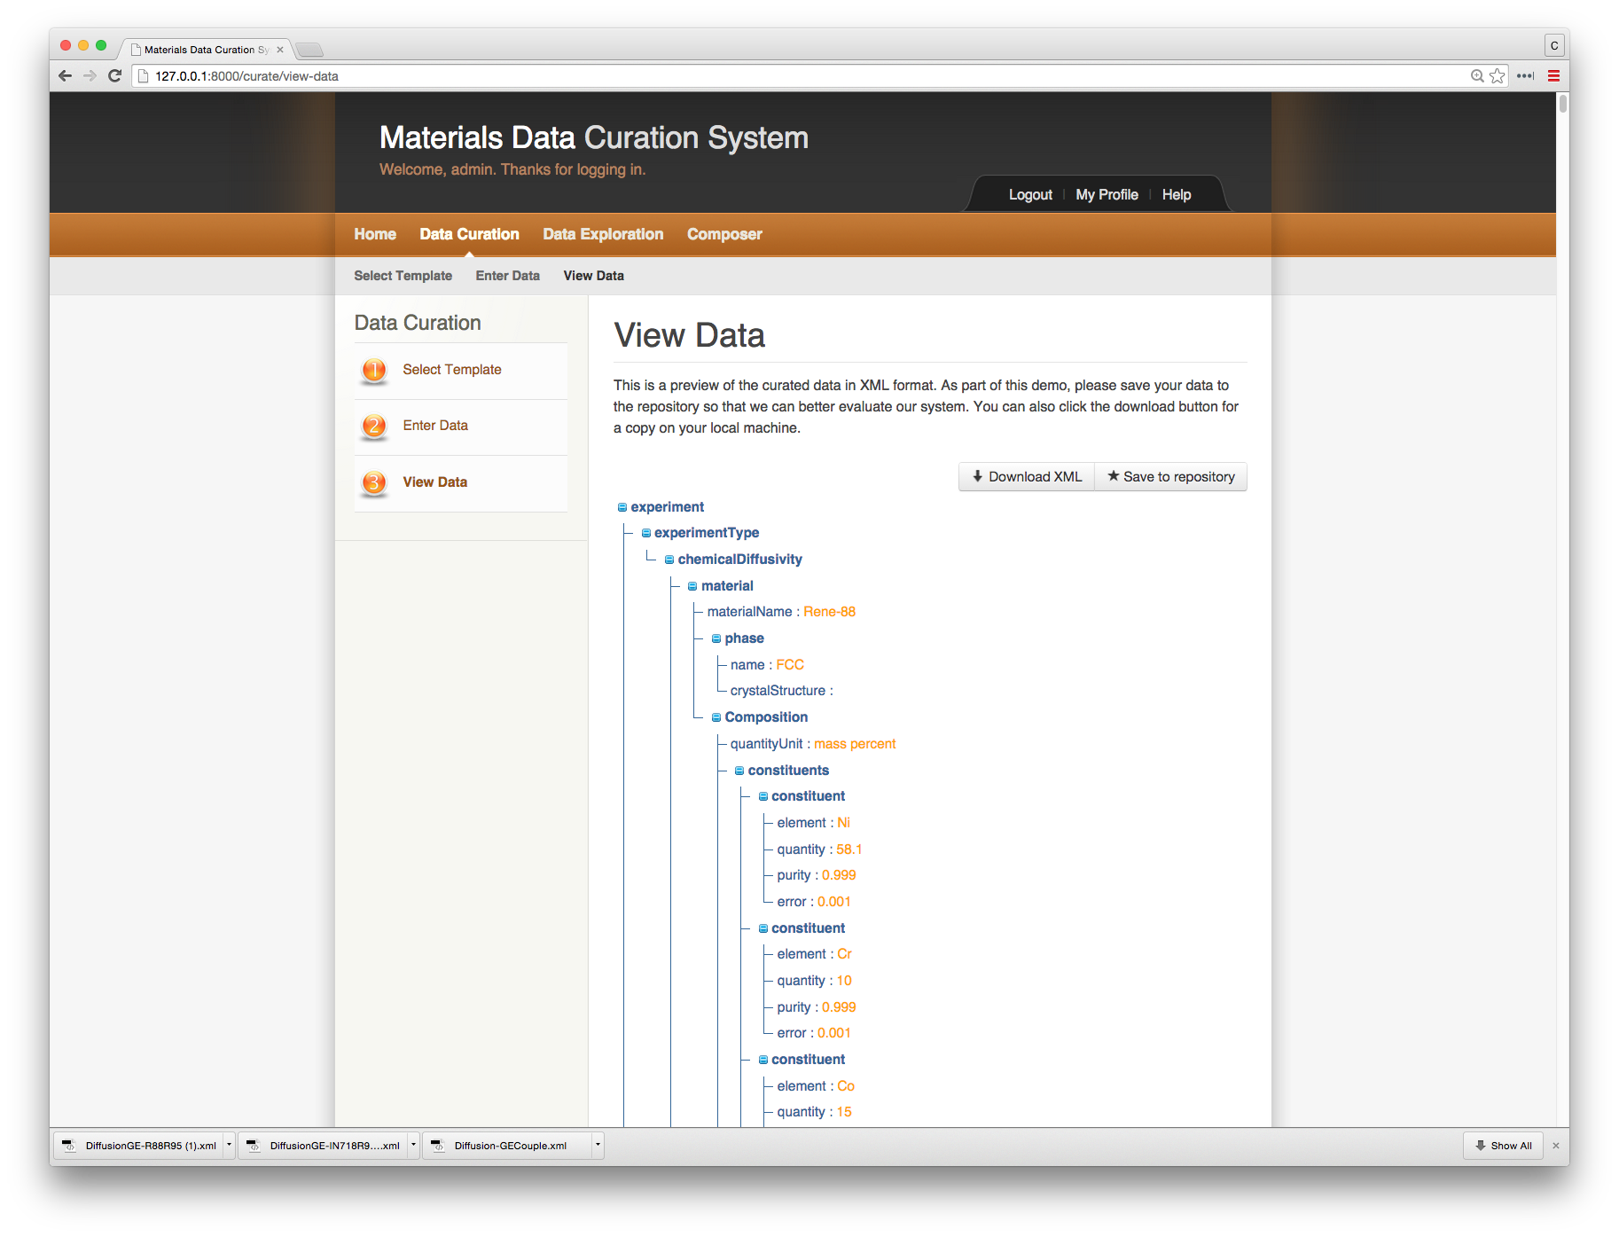

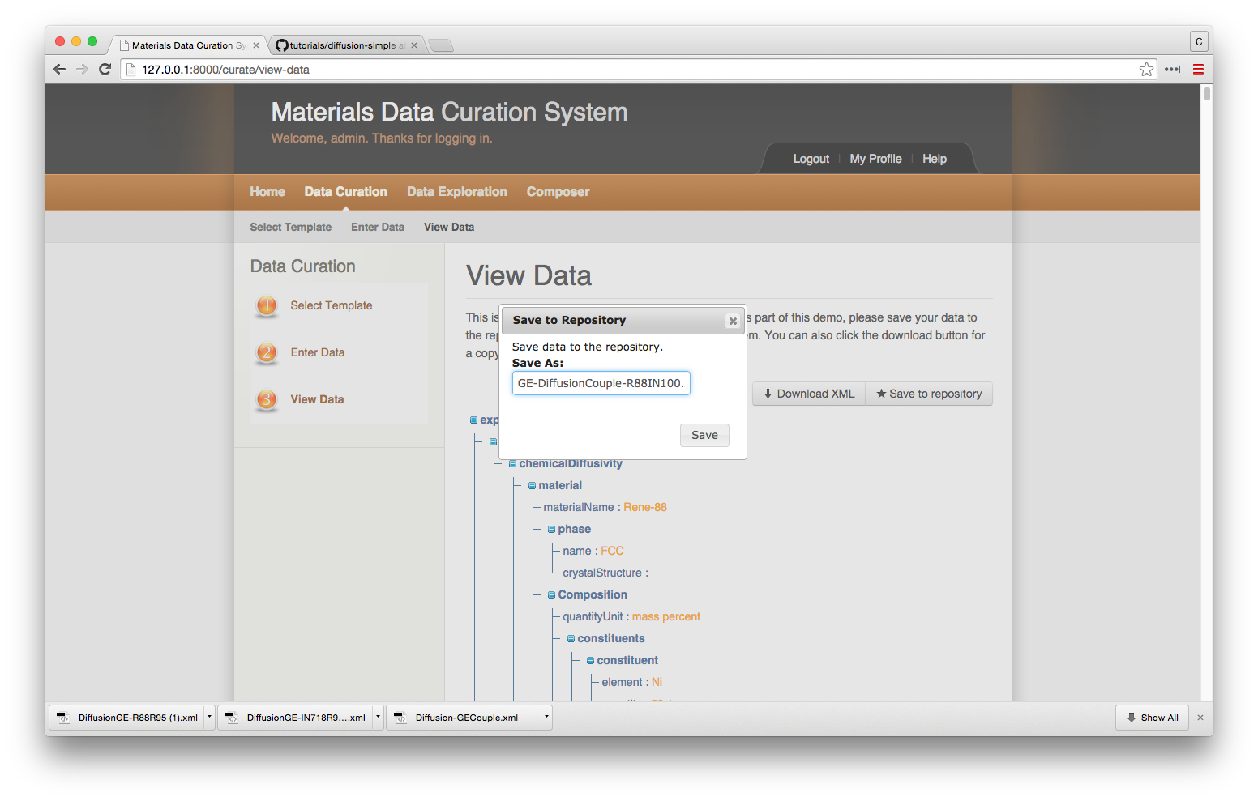

You can also download a copy of the XML entry.



In the “Data Exploration” tutorial we will then view this data and export the spreadsheet.